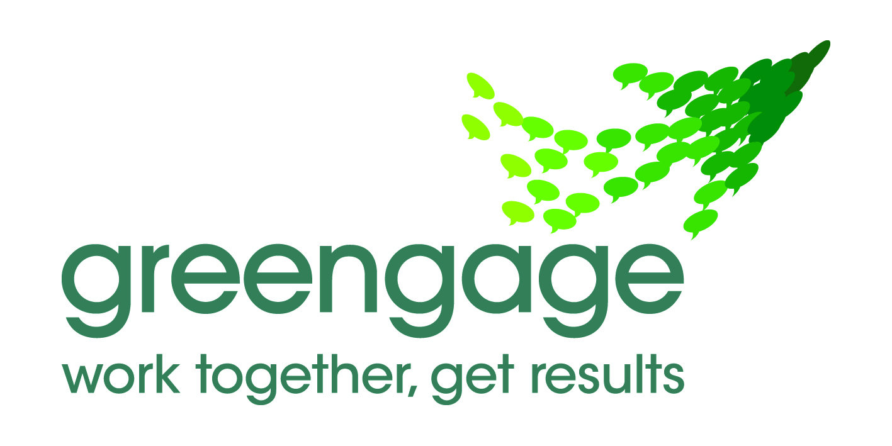 | Lancashire Shadow Health and Wellbeing Board  Intervention planning

Purpose

This report sets out a template for use in preparation of the work programme for each of the Health and Wellbeing Board’s ten interventions. The template is designed to;

- Create clarity on the desired impact of each intervention and on the specific roles of partners in delivering the intervention.

- Make explicit the shifts in ways of working that will allow partners to deliver the intervention.

The planning template

- Reality
What’s the current reality?

- What is currently working well?

Lancashire Home Energy Group attended by all Lancashire Districts and the County Council includes a strong officer base with specialist and local knowledge. The Groups remit is to work in partnership to improve the energy efficiency of Lancashire Homes, addressing health inequalities exacerbated by living in cold damp homes, and reducing fuel poverty. The Group has a good track record of working in partnership and establishing appropriate links with the insulation industry and the energy providers.

Existing partnerships have helped to ensure that insulation installation rates in some areas of Lancashire are amongst the highest in the Country. Given this experience Lancashire is in a position to capitalise on existing partnerships to deliver home energy insulation at volume, across other areas of Lancashire, for the remaining duration of CERT.

Last winter Lancashire submitted bids to the Department of Health Warm Homes Healthy People Fund and successfully delivered a number of projects across the County. New partnerships were established and delivered wide-ranging interventions targeted at preventing cold related deaths and illnesses. The interventions included: emergency heating repairs, boiler servicing, draught proofing, fuel poverty training for front line staff, emergency heaters, fuel payments, food parcels, benefit checks, winter warmth packs, referrals to free loft and cavity wall insulation schemes and the gritting of paths.
Building on the initiatives and partnerships established last winter, with the potential for the more effective supply of health related referrals from PCTs and GPs, via this proposed affordable warmth intervention, Lancashire affordable warmth partnerships are primed to deliver breakthrough results in reduced visits to GPs surgeries, reduced hospital admissions and ultimately reduced excess winter deaths.

Home Improvement Agencies (HIA’s) are operating across Lancashire. These agencies provide a range of housing related support to older and/or vulnerable people to maintain, improve and adapt their homes to maintain independence and improve wellbeing. Specific works reduce fuel poverty and tackle poor housing conditions that exacerbate chronic illnesses and reduce the risk of accidents in the home. These agencies could be mobilised into coordinated, health-led, affordable warmth activity.

- Where are the gaps in service delivery that really matter?

Energy efficiency measures and other actions that protect people from the effects of cold weather need to be targeted at those that are most at risk of suffering ill health and poor wellbeing from the cold weather. Effective referrals are required from hospitals, GPs and Social Care.

The removal of fuel poverty as a national indicator coupled with reducing local authority financial resources may have led to less emphasis on this area of work in the last 18 months and so a joint approach with Health input could provide the catalyst for affordable warmth to move up the agenda in local authorities.

We need to identify the at risk groups and then get them the right help, in an effective and timely manner, however these measures are not integrated into long term condition care pathways routinely across the county.

Lancashire needs an effective referral pathway with a single point of access that will allow front line health and social care professionals to refer people at risk of ill health due to cold and poorly heated homes, to a range of evidence based affordable warmth measures.

Referrals are currently not routinely made by social care and health services due to confusion of where to refer for particular interventions, initial research shows practitioners want a straight forward referral system and confidence that referrals will be followed up. Most Home Improvement Agencies and housing enforcement teams are working at full capacity and so in some areas we will need to either increase capacity or move capacity from other (lower priority) areas of work.

Emergency funds are required and not huge funds either….. winter 2011/12 Warm Homes Healthy People funding from the Department of Health evidenced what can be delivered with modest, targeted funding (see results section).

- What are the issues and opportunities that must be addressed if we are to make a breakthrough? i.e. what really matters?

Systematically offering affordable warmth measures by identifying those at greatest risk of cold related ill health from , GPs through primary care disease registers, social care services and other hospital services and others working with those with long term conditions –including an effective referral service, see above.

We would like to see hospital/health based Home Improvement Agency staff available to give advice and coordinate home visits, upon or preferably pre-discharge.

Targeted enforcement of private rented sector landlords to provide at least minimum statutory standards in private rented housing. The private rented sector continues to consistently contain the poorest housing conditions.

We need to maximise the uptake of free loft and cavity wall insulation via CERT for the remainder of the scheme (it is anticipated that CERT will finish in December 2012).

We must be ready to maximise the opportunities that may come out of the Governments ‘Green Deal’ and the associated energy company obligations which is currently a developing area of policy.

2. Results
What does success look like?

2.1 Longer-term impact

- What will be the 3 to 5 year impact of the intervention?

The overall goal of the initiative is to reduce the negative impact of cold, damp homes upon the health and well being of our most vulnerable residents.

Reduced demand for NHS services specifically reduced excess unplanned hospital admissions for respiratory and circulatory diseases in the winter, reduced visits to GPs surgeries, reduced excess winter deaths. Reduction in health inequalities.

Improved housing, lower fuel bills for clients, older people better able to maintain independence, support provided will help vulnerable people to maintain their tenancies, individuals mental as well as physical wellbeing will be improved.
Reduced exacerbations of childhood asthma. Reduced isolation (evidenced that particularly older people living in cold, damp homes are not inclined to encourage visitors). Those with long term conditions will be better able to maintain independence at home. Supports healthy maternal health and early years.

Other wider and positive impacts of home improvement agency access to these vulnerable clients will be seen for example, clients will access handy person services and so we will see reduced slips/trips/falls, benefit checks will result in increased household incomes and so additional money for household bills (including fuel). To give an idea of the potential scale of this in Wyre and Fylde for example between April 2011 and March 2012 Care & Repair assisted older and disabled residents in Wyre and Fylde to make £557,585 per annum of new claims for Attendance Allowance and £58,164 per annum in other benefits. That is a massive increase in income for residents of £615,749 per annum, with some couples receiving as much as £8054.80 additional income per year.

What are the longer-term measures of success?

- reduced excess winter deaths
- reduced excess winter hospital admissions (conditions associated with cold weather respiratory, cardiovascular and hypothermia)
- reduced number of visits to GPs
- Improved housing – reduction in category 1 excess cold hazards.
- Reduced Fuel Poverty of high risk groups
- Reduced fuel bills for individuals
- Contribution to achievement of all age all cause mortality targets (and consequently reducing inequalities in life expectancy within the area)
- Improved health, wellbeing and life expectancy of vulnerable groups
- Reduced winter planning pressures on NHS, social care and other relevant organisations
- Reduced non-elective admissions to hospital
- Increased household incomes
- Reduced costs to NHS/health services due to fewer presentations /admissions

2.2 Impact in the year ahead

What specific goals will the intervention achieve in the next year?

Depending on the ability to secure some resources for implementation of a referral system and an emergency fund for minor repairs, it would be possible to deliver a number of affordable warmth interventions to those who need them most.

As an example, for a sum of £17,000 Wyre and Fylde Care and Repair delivered 141 interventions that included: the repair of 11 heating systems, the servicing of 23 boilers, the distribution of 29 emergency heaters, the distribution of 10 food parcels, draught proofing measures for 30 homes, emergency fuel payments, a supply of grit sufficient to grit the paths of 300 homes and clients were referred for free loft and cavity wall insulation via CERT and, for those eligible, heating systems via Warm Front.

In excess of 5,000 Vulnerable individuals across Fylde and Wyre including the elderly, low income groups and disabled people received information and advice on how to cope with the cold weather during the winter months.

52 professionals working with vulnerable groups across Fylde and Wyre were trained on how to identify when people are in fuel poverty; the health impacts of living in fuel poverty; basic energy efficiency advice; low cost / no cost energy efficiency measures; and where to signpost people for help and advice;

If this were to be rolled out across Lancashire, the impact would be significant.

- What are the specific measures of success for the year ahead?
- How will the Health and Wellbeing Board know that the intervention has achieved its goals?

Some possible measures could be

- The delivery of an additional loft and cavity wall insulation across Lancashire
- The number of Category 1 excess cold Hazards in private rented sector homes addressed
- The number of referrals leading to an intervention to improve a households affordable warmth.
- The number of reduced visits to GP’s surgeries
- The number of vulnerable households benefiting from affordable warmth interventions.

- Response
What needs to happen to ensure partners achieve better results?

  - Shifts in the way that partners deliver services

- How must partners work to ensure that the ‘priority shifts’ are applied and the intervention is effectively implemented?

Partners need to work together to support the referral system and identify those most in need, this will require better data sharing, Joint working will also be important e.g. hospital based HIA staff. This will reduce demand for acute and residential services, reduce bed blocking and the return of patients back into the health system due to cold. HIA teams and partners will help to deliver accessible services in the community and maintain individual’s independence.

  - Programme of work

- Who needs to be involved to develop, commission and deliver the intervention?

HIAs, Districts – Private Sector Housing Teams, LCC, Public health teams, Registered social landlords, Hospitals, CCGs, GP’s, Community nurses, Social Care, Trading Standards, Third Sector
- What are the ‘milestones’ for the Task Group in the year ahead?

Launch and engage partners in an effective referral system with a single point of access, that gets help to people who are most at risk of ill health from cold conditions, and makes the most efficient use of the HIA and other services available. (The design of this should be informed by the current review of the referral process across Lancashire).
Developing an effective information sharing system with health professionals to enable targeting of those with long term health conditions and other vulnerable groups
Increased uptake of energy efficiency measures through CERT funding and /Warm Front

Participation in the 12/13 winter warmth campaigns by Districts, health, CCG’s, LCC (Public Health, Social Care), Home Improvement Agencies, CAB, RSL’s and third sector partners (inc. CAB).

Planning and preparation for an effective Green Deal and ECO in Lancashire.

- What are the specific activities to be carried out by each partner?
- Districts, LCC, CCGs and hospitals to work together to design, launch and to put in place (including awareness raising amongst front line professionals) an effective referral system coordinated by the Lancashire Energy Officers Group?

- Identify and put in place an effective response to the referral process (referral pathway / establishing what happens next in each locality). For example insulation of energy efficiency measures, income maximisation, and fuel debt advice.

- Determination of resources available to support Affordable Warmth intervention, in particular funding to be used for emergency winter warmth interventions
- Coordination of Lancashire wide 12/13 winter warmth programmes – establishment of ‘footprint’ leads to take local programmes forward.

- Mapping of local community health contacts is required – community matrons, occupational health, hospital discharge teams etc, to raise awareness of the new referral mechanisms.

- Engagement with CCG’s on developing CCG Business Plans

- Work to include actions to address affordable warmth as part of discharge planning.

- Evaluate WHHP projects and the PCT funded projects in Lancaster, Wyre and Fylde for potential roll out.

